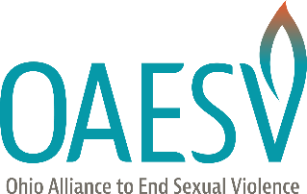
9th Annual Advocacy Day to End Sexual Violence

Tip Sheet on Policy Conversations
- Know the Lawmaker’s Background:
Ohio lawmakers bring an array of experiences to the Statehouse floor. Many are current or former
teachers, farmers, lawyers, nurses and doctors, finance professionals, judges, and small business owners. It is extremely helpful to review the lawmaker’s biography ahead of the meeting to anticipate the lens through which the lawmaker will analyze the topic. For example, a former prosecutor will likely view your content through a criminal justice perspective, where a former teacher will likely think of the direct impact on children and families.
- Embrace your own Expertise:
Lawmakers lean on their own experience when evaluating policy, but they also recognize
and value experts across various fields. This is a topic on which few lawmakers can claim professional expertise. They know you are an expert and they want to learn from your experiences and perspective.
- The questions may not always align:
Because lawmakers bring varying perspectives, their questions are often rooted in their professional
experiences. They may ask about potential alternatives or additional possible solutions to problems, not to disparage the original idea, but to provide additional help. This is especially common when lawmakers have criminal justice experience. It can be helpful to say “I think that could potentially be quite helpful, I will let our partners at OAESV know and they will connect with you to follow-up.” Should a suggestion arise, please record it in your survey so that OAESV knows to reach out.
- Don’t Worry about Filling Time
With daily COVID-19 changes across the state government and staffers juggling home and work lives,
teams are very busy and will appreciate brevity.
- Acknowledge the Current Situation
It is important to acknowledge that lawmakers are navigating the challenge of partial in-person
legislating, working with vaccine distribution, continued infection increases, and other challenges as
we round out a full year of social distancing. Unlike last year, we see light at the end of the tunnel and can anticipate life after COVID – meaning we will address many points with an eye toward the future but also want to thank them for supporting survivors and our work with COVID funding and other support during the last thirteen months.
- Send a thank you email and follow-up if they request further information
If you need information on how to reach the aide or lawmaker you spoke with, please do not hesitate to ask OAESV for assistance. If the lawmaker asks for information, do your best to follow-up and let OAESV know if we can support you in this endeavor.

